PREDICTION OF CYBER ATTACKS USING DATA SCIENCE TECHNIQUE

Thesis Submitted to RAJENDRA UNIVERSITY for the award of the degree of Bachelor of Computer Applications

By
Ayush Das
(Roll no. R05423BCA009)
Department of BCA, YCAT, Sakma, Balangir

Under the Supervision of Dr. Jagamohan Padhi (Guide)
Associate Professor,
Principal, YCAT (Professional), Sakma, Balangir



RAJENDRA UNIVERSITY
PRAJNA VIHAR, BALANGIR, ODISHA-767002

Year 2026

CERTIFICATE

This is to certify that the thesis titled “ PREDICTION OF CYBER ATTACKS USING DATA SCIENCE TECHNIQUE “, submitted to Yuvodaya College of Advanced Technology, Sakma, Balangir affiliated to Rajendra University, Odisha , India by Ayush Das, Roll No. R05423BCA009 for the award of the degree of Bachelor of Computer Applications is a Bonafide record of research work carried out by her under my supervision and guidance.

The candidate has fulfilled all the requirements.

The thesis, which is based on the Candidate’s own work, has not been submitted elsewhere for a degree/diploma

In my opinion, the thesis is a standard requirement for a bachelors degree.

Dr. Jagmohan Padhi
Associate Professor,
External Principal,
YCAT, Sakma, Balangir Odisha 767020 (INDIA)

DECLARATION

I certify that
- The work contained in this thesis is original and has been done by myself under the supervision of my supervisor.
- This work has not been submitted to any other institute for any degree or diploma.
- I have confirmed the norms and guidelines provided in the Ethical code of Conduct of the Rajendra University
- Whenever I have used materials (data, theoretical analysis, and text ) from other sources, I have given due credit to them by citing them in the text of the thesis and giving their details in the references.
- Whenever I quote written materials from other sources, credit is given to the sources by citing them.
- From the plagiarism test , it was found that the similarity index of the whole thesis is less than 15% as per the University Grant Commission guidelines, which is within 25
% and less than 10% from a single paper as per the university guidelines.

Date:

Place:

Name: Mr. Ayush Das
Roll No.: R05423BCA009

ACKNOWLEDGEMEN

I would like to express my deepest gratitude to my supervisor, Dr. Jagamohan Padhi , for their invaluable guidance, constant encouragement, and unwavering support throughout the course of this research. Their insightful feedback and expertise have been instrumental in shaping this thesis, and I am deeply grateful for their patience and dedication.
I would also like to extend my heartfelt thanks to Dr. Jagamohan Padhi, the Principal of Yuvodaya College of Advanced Technology, Sakma , Balangir, for his continuous support and encouragement. His leadership and commitment to academic excellence have greatly contributed to the successful completion of this work.
I would also like to acknowledge the Yuvodaya College of Advanced Technology, Sakma , Balangir for providing the necessary resources, facilities, and academic environment that facilitated the completion of this research. The access to library resources, research materials, and technical support was critical to the success of this study.
A special note of appreciation goes to my Girlfriend, who has always been there to offer support, encouragement, and constructive criticism. Her companionship and insights have made this journey more enriching and memorable.
Finally, I wish to thank my family and friends for their unconditional love, support, and understanding throughout this entire process. Without their belief in me, this work would not have been possible.

ABSTRACT
In the context of a digitally transforming world where interconnectivity of networks is rapidly expanding, the threat of cyber-attacks, including ransomware, state-sponsored cyber-attacks, etc., is increasing exponentially in terms of frequency, complexity, and variety. Cybersecurity has emerged as one of the pillars of digital resilience. This thesis explores the synergistic potential of integrating data science methodologies as well as supervised machine learning approaches for the development of proactive predictive cyber threat detection and classification systems, beyond the limitations of reactive approaches, which are proven inadequate in coping with the dynamic, non-linear, and high-dimensional nature of network traffic patterns.
In light of the limitations of existing approaches, including feature complexity, generality, and high false positives, the thesis treats intrusion detection as a multi-class classification problem. The approach involves a rigorous data analysis pipeline including data preprocessing, feature analysis, anomaly detection, as well as hyperparameter tuning. Four machine learning approaches, namely Logistic Regression, Decision Tree, Random Forest, and Support Vector Classifier, are systematically compared using the NSL KDD dataset. Performance is evaluated using rigorous metrics including accuracy, precision, recall, as well as F1-score, while placing greater emphasis on real-time adaptability as well as low false alarms.
In the context of the proposed approach, the intrusions are classified into four main categories: Denial of Service (DoS), Remote-to-Local (R2L), User-to-Root (U2R), as well as Probe attacks. The experimental findings substantiate the efficacy of the suggested methodology; specifically, the refined machine learning models successfully discern patterns within the training dataset, thus yielding enhanced predictive accuracy relative to conventional methods. This approach incorporates data science techniques alongside evolutionary optimization principles, consequently facilitating the creation of intelligent, self-evolving intrusion detection systems, which possess the capacity to proactively forecast cyber threats.
In conclusion, the proposed approach contributes to the development of data-driven cybersecurity architectures, empowering organizations to proactively defend themselves against cyber-attacks, thereby promoting a more secure as well as trustworthy digital environment in the context of an increasingly interconnected world.

TABLE OF CONTENTS

CHAPTER NO | TITLE | PAGE  NO
 | ABSRACT
 | LIST OF FIGURES
 | LIST OF TABLES
1 | INTRODUCTION
 | 1.1 Data Science | 1
 | 1.2 Machine Learning | 1
 | 1.3 Objectives | 2
 | 1.4 Project Goals | 2
2 | LITERATURE SURVEY
 | 2.1 Literature Survey | 3
3 | AIM AND SCOPE OF THE INVESTIGATION
 | 3.1 Project Proposal | 6
 | 3.2 Scope of the Project | 6
 | 3.3 Existing System | 6
 | 3.3.1 Disadvantages | 7
 | 3.4 Preparing Dataset | 7
 | 3.5 System Study | 7
 | 3.6 Feasibility Study | 10
4 | EXPERIMENTAL OR MATERIALS AND METHODS, ALGORITHMS USED
 | 4.1 Project Requirements | 11
 | 4.2 Software Description | 12
 | 4.3 Python Libraries Needed | 13
 | 4.4 System Architecture | 13
 | 4.5 UML Diagrams | 14

 | 4.6 Algorithms Used | 15
 | 4.7 Comparing Algorithm with prediction in the form of best  Accuracy result | 16
 | 4.8 Module Description | 16
5 | RESULTS AND DISCUSSION, PERFORMANCE ANALYSIS
 | 5.1 Performance Analysis | 17
 | 5.2 Discussion | 19
6 | SUMMARY AND CONCLUSION
 | 6.1 Summary | 19
 | 6.2 Conclusion | 19
 | 6.3 Future Work | 19
 | REFERENCES | 20

LIST OF FIGURES

FIGURE NO | FIGURE NAME | PAGE NO
1.1 | Process of Machine Learning | 2
3.1 | Process of data flow Diagram | 11
4.1 | System Architecture | 14
4.2 | Use Case Diagram | 14
4.3 | Activity Diagram | 14
4.4 | Entity Relationship Diagram | 15
5.1 | Accuracy comparison of DOS Attack | 17
5.2 | Accuracy comparison of R2L Attack | 17
5.3 | Accuracy comparison of U2R Attack | 18
5.4 | Accuracy comparison of Probe Attack | 18
5.5 | Accuracy comparison of Overall Attack | 18

LIST OF TABLES

TABLE NO | TABLE NAME | PAGE NO
3.1 | Attack Types Grouped to respective class | 7
3.2 | Description of Attacks | 8

CHAPTER-1 INTRODUCTION

DOMAIN OVERVIEW
  - DATA SCIENCE
Data science is an interdisciplinary field that uses scientific methods, processes, algorithms and systems to extract knowledge and insights from structured and unstructured data, and apply knowledge and actionable insights from data across a broad range of application domains.

The term "data science" has been traced back to 1974, when Peter Naur proposed it as an alternative name for computer science. In 1996, the International Federation of Classification Societies became the first conference to specifically feature data science as a topic. However, the definition was still in flux.

Data science can be defined as a blend of mathematics, business acumen, tools, algorithms, and machine learning techniques, all of which help us in finding out the hidden insights or patterns from raw data, which can be of major use in the formation of big business decisions.

  - MACHINE LEARNING (ML) :

Machine learning is a way to predict what might happen in the future by looking at past data. It is a type of artificial intelligence that allows computers to learn on their own, without being programmed step by step. The main focus of machine learning is to create computer programs that can change and improve when they are given new data. It also covers the basics of machine learning and shows how to implement a simple machine learning algorithm using Python. The process of training and making predictions involves using special algorithms. These algorithms are given training data, and then they use that data to make predictions about new, unseen data. Machine learning can generally be divided into three main categories: supervised learning, unsupervised learning, and reinforcement learning. In supervised learning, the program is given both input data and the correct answers, which are labeled by a human in advance. In unsupervised learning, the data is not labeled, and the algorithm must find patterns or group similar data on its own. Reinforcement learning is different because it involves an algorithm

interacting with its environment and learning from the feedback it receives, either positive or negative, to improve how it performs.
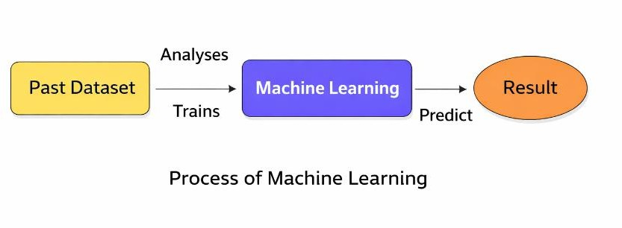
Fig 1.1: Process of Machine Learning

  - OBJECTIVES:
This analysis focuses on identifying which features are most useful in predicting different types of network attacks, including DOS, R2L, U2R, Probe, and combinations of attacks. It also aims to uncover general trends that can assist in choosing the best model and tuning its hyperparameters. To do this, machine learning classification methods were used to build a model that can predict the discrete class of new input data.

The repository is a learning exercise meant to:
    - Apply fundamental machine learning concepts using an available dataset, evaluate and interpret the results, and justify the interpretation based on the observed data.
    - Create notebooks that act as computational records, documenting the thought process and investigating whether a network connection is under attack, in order to analyze the dataset.
    - Evaluate and analyze statistical and visualized results to identify standard patterns across all categories.

  - PROJECT GOALS:

Exploration data analysis involves identifying variables
- Loading the dataset provided
- Importing necessary libraries and packages
- Examining the general characteristics of the data
- Finding duplicates and missing values
- Checking unique values and their counts

Exploration data analysis for single variable data
- Renaming, adding, and removing data as needed
- Specifying the data types
Exploration data analysis for two or more variables
- Creating visualizations such as pair plots, heatmaps, bar charts, and histograms Method for detecting outliers and performing feature engineering
- Preprocessing the dataset
- Splitting the data into testing and training sets
- Comparing the Decision Tree, Logistic Regression, and Random Forest models

Comparing different algorithms to predict the outcome
- Based on which model provides the best accuracy

CHAPTER 2 LITERATURE SURVEY
2.1 LITERATURE SURVEY
A literature review is a type of writing that looks at the important ideas and methods used in studying a specific topic. It uses existing research, or secondary sources, to discuss information in a certain subject area, often focusing on what has been written about it within a specific time frame. The main purpose is to help readers understand the latest research on a topic and can serve as a foundation for future research or as part of a research proposal. It can also be a simple summary of what has been written. Typically, it has a clear structure and
includes both summaries and syntheses of the sources.

REVIEW OF LITERATURE SURVEY

Title: A Prediction Model of DoS Attack’s Distribution Discrete Probability
Author: Wentao Zhao, Jianping Yin and Jun Long
Year: 2008
The prediction analysis makes use of historical and present data for making predictions about future. When we talk about detecting DoS attacks in networking security, then it

becomes very important yet very difficult because traditional techniques of detection require preexisting knowledge. This research paper provides a methodology which incorporates the concepts of clustering, genetic algorithms, and Bayes theorem for prediction analysis.

Title: Apriori Viterbi Model for Prior Detection of Socio-Technical Attacks Social Network
Author: Preetish Ranjan, Abhishek Vaish
Year: 2014
The socio-technical attack includes using technology for malicious purposes that lead to unrest and destabilization in social structures that are based on trust. Content that poses a threat can worsen any problem in the society, especially if the content targets sensitive issues. It is difficult to detect socio-technical attacks because of their complexity. The Apriori and Viterbi algorithm can assist in predicting attacks by analyzing data from communication channels.
Title: New Attack Scenario Prediction Methodology
Author: Seraj Fayyad, Cristoph Meinel
Year: 2013
IDSs are used for the surveillance of IT systems in order to detect and trigger alerts on suspicious behavior. The alert can be duplications or can also be considered a part of a multi- staged attack scenario in which the activities are causally related. The attack is usually initiated by conducting reconnoitering and fingerprinting in order to obtain system information. The suggested approach is a real-time method that employs past data and attack graph generation for the prediction of possible attack activities without intensive computations.

Title: Cyber Attacks Prediction Model Based on Bayesian Network
Author: Jinyu W1, Lihua Yin and Yunchuan Guo
Year: 2012
The prediction of cyber-attacks provides information on future threats concerning network security and facilitates proactive defense against them. One of the main parameters is the probability of attack, which measures the chance of an intrusion occurring. Graphs such as the attack graph provide the means by which to predict such attacks; considering parameters such as value of assets, use of the network, and previous attacks increases the accuracy of such predictions. A suggested approach integrates attack graphs with Bayesian networks.

Title: A Prediction Model of DoS Attack’s Distribution Discrete Probability
Author: Wentao Zhao, Jianping Yin
Year: 2008
This paper starts by exploring the connection between network traffic data and the level of DoS attack activity. It then introduces a clustering method that uses a genetic optimization algorithm to classify DoS attack data. The approach first establishes an accurate relationship between network traffic and DoS attack levels through optimized clustering, and then creates prediction sub-models for DoS attacks. Using the Bayesian method, the paper calculates the probability outputs for each sub-model, allowing for a prediction of the distribution of DoS attack levels in the future. The paper first outlines the clustering problem and then applies the genetic algorithm to refine clustering techniques. Based on this optimized clustering of sample data, various categories of the relationship between traffic and attack levels are identified, leading to the creation of multiple prediction sub-models for DoS attacks. Additionally, the Bayesian approach is used to calculate discrete probabilities for each sub-model, resulting in a discrete probability prediction model for DoS attacks.

Title: Adversarial Examples: Attacks and Defenses for Deep Learning
Author: Xiaoyong Yuan, Pan He, Qile Zhu, and Xiaolin Li
Year: 2019
It looked at the latest discoveries about adversarial examples in deep neural networks. We studied the current techniques used to create adversarial examples. A classification system for these examples was introduced. We also looked into how adversarial examples are used and the ways to protect against them. This paper aimed to cover the most up-to-date research on adversarial examples within the deep learning field. When compared to recent studies, we examined the current issues and possible fixes related to adversarial examples. However, deep neural networks have been found to be weak against specially crafted input samples known as adversarial examples. These perturbations are nearly invisible to humans but can trick DNNs during testing or when they are in use. The risk posed by adversarial examples has become a big concern when applying DNNs in important safety areas. Because of this, both attacking and defending against adversarial examples have become widely studied topics. In this paper, we review the recent developments on adversarial examples for DNNs, summarize the methods used to generate them, and suggest a classification of these methods. Within this classification,

we examine the applications of adversarial examples. We also go into detail about the strategies to counter them. Additionally, we discuss three main challenges in dealing with adversarial examples and the possible solutions to these challenges.

CHAPTER-3
AIM AND SCOPE OF THE PRESENT INVESTIGATION

  - PROJECT PROPOSAL
The idea is to create a machine learning model that can detect anomalies. Anomaly detection is a key method for spotting things like fraud, unusual activities, network attacks, and other irregular events that are important but hard to find. To build the model, we use data science techniques such as identifying the right variables, which include both the factors we're looking at and the ones that influence them. We also visualize the data to better understand the patterns and insights within it. The model is developed using past data, allowing the algorithm to learn from it. Different algorithms are tested to find the best one, and then we calculate and compare the performance metrics to evaluate how well each one works.
  - SCOPE OF THE PROJECT
The scope of this project is to look into a dataset that includes network connection attacks, specifically for the medical sector, using machine learning methods. The aim is to determine whether a network connection is under attack or not.
  - EXISTING SYSTEM
They suggested starting with a contrastive self-supervised approach to tackle anomaly detection in attributed networks. Their method, called CoLa, includes three main parts: contrastive instance pair sampling, a GNN-based contrastive learning model, and a multi-round sampling method for calculating anomaly scores. Their model focuses on understanding the connection between each node and its surrounding structure, and it uses an objective related to anomalies to train the contrastive learning model. We think this framework offers a new way to bring self-supervised and contrastive learning into more graph-based anomaly detection tasks. The scores generated through multiple rounds by the contrastive learning model are then used to assess how abnormal each node is, based on statistical analysis. The process has two

stages: training and inference. During training, the contrastive learning model is trained using sampled instance pairs without needing labeled data. Then, during inference, the model produces anomaly scores for each node.

Disadvantages:
- The performance is not good and it get complicated for other networks.
- The performance metrices like recall F1 score and comparison of machine learning algorithm is not done.
  - PREPARING DATASET:
This Dataset contains 3000 records of features. It is classified into 4 classes.
- DOS Attack
- R2L Attack
- U2R Attack
- Probe Attack
  - STSTEM STUDY
The KDD Cup99 data set consists of normal network traffic and 22 different attacks that are represented by 41 attributes. Every instance in the traffic dataset is classified and assigned to one of four broad categories, including DoS, U2R, R2L, and Probing attacks. DoS attacks flood the system to block legitimate users from accessing it. U2R attacks consist of escalating privileges from regular user access to root access. R2L attacks provide attackers with access to the local environment through a remote connection and typically exploit social engineering. Probing attacks scan networks for weaknesses and available services. Both discrete and continuous attributes are present in the dataset, helping to interpret the behavior of attacks.
This chapter outlines the structure of the dataset used in the proposed work. The various kinds of features such as discrete and continuous features are studied with a focus on their role in the attack. The attacks are classified with a brief introduction to each. The next chapter discusses the clustering and classification of the data with a direction to learning by machine.

Dos | R2L | U2R | Probe
Back | FTP Write | Load mosule | Ip sweep

Neptune Land Pod Smurf Teardrop Apache2  Mail bomb Process table UDP Storm | Multihop Phf  Spy Warezclient Warezmaster Imap  Guess password http tunnel named  send mail snmpget attack snmp guess worm  xlock xsnoop | Rerl Rootkit  Buffer overflow Ps  Sql attack xterm | Nmap Satan  Port sweep Msscan saint
Table 3.1: Attack Types Grouped to respective Class

Types of  Attacks | Description
back | Denial of service attack against apache web server where a  client requests a URL containing many backslashes
neptune | Syn flood denial of service on one or more ports
land | Denial of service where a remote host is sent a UDP packet  with the same source and destination
pod | Denial of service ping of death
smurf | Denial of service icmp echo reply flood

teardrop | Denial of service where mis-fragmented UDP packets cause  some systems to reboot
multihop | Multi-day scenario in which a user first breaks into one machine
phf | Exploitable CGI script which allows a client to execute  arbitrary commands on a machine with a mis-configured web server.
spy | Multi-day scenario in which a user breaks into a machine with the purpose of finding important information where the user tries to avoid detection. Uses several different exploit  methods to gain access
warezclient | Users downloading illegal software which was previously  posted via anonymous FTP by the warezmaster
warezmaster | Anonymous FTP upload of Warez (usually illegal copies of  copy writed software) onto FTP server
Imap | Remote buffer overflow using imap port leads to root shell
loadmodule | Non-stealthy loadmodule attack which resets IFS for a  normal user and creates a root shell
Perl | Perl attack which sets the user id to root in a perl script and  creates a root shell
rootkit | Multi-day scenario where a user installs one or more  components of a rootkit
ipsweep | Surveillance sweep performing either a port sweep or ping on multiple host addresses
nmap | Network mapping using the nmap tool. Mode of exploring  network will vary-options include SYN

satan | Network probing tool whichlooks for well-known  weaknesses. Operates at three different levels. Level 0 is light
portsweep | Surveillance sweep through many ports to determine which  services are supported on a single host
dict | Guess passwords for a valid user using simple variants of  the account name over a telnet connection
eject | Buffer overflow using eject program on Solaris. Leads to a  user->root transition if successful
ffb | Buffer overflow using the ffbconfig UNIX  system command leads to root shell
format | Buffer overflow using the fdformat UNIX system command  leads to root shell
ftp-write | Remote FTP user creates .rhost file in world writable  anonymous FTP directory and obtains local login
guest | Try to guess password via telnet for guest account
syslog | Denial of service for the syslog service connects to port 514  with unresolvable source ip
warez | User logs into anonymous FTP site and creates a hidden  directory
Table 3.2 Description of attack

  - FEASIBILITY STUDY
The feasibility study outlines key steps in preparing and analyzing data for phishing detection. It begins with data wrangling, where the dataset is loaded, cleaned, and refined for accurate analysis. Data collection involves splitting the dataset into training and testing sets, typically in a 7:3 ratio, and applying algorithms like Random Forest, Logistic Regression, Decision Tree,

and Support Vector Classifier. Preprocessing ensures data quality by handling missing values, removing outliers, and converting variables appropriately. Finally, the classification model, particularly Random Forest, is highlighted for its strong performance, ability to handle diverse data types, robustness against noise, and reliable accuracy estimation using out-of-bag error.
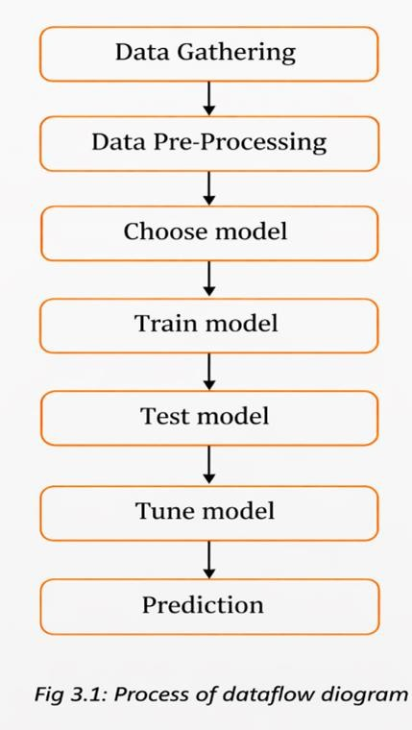

CHAPTER-4
EXPERIMENTAL OR MATERIALS AND METHODS; ALGORITHMS USED
  - PROJECT REQUIREMENTS:

Requirements define the essential constraints needed to develop a system and are identified during the design phase. They are broadly categorized into functional, non- functional, and environment requirements. Functional requirements describe the system’s specific needs and are documented in the Software Requirements Specification (SRS), including the use of libraries such as Scikit-learn, Pandas, NumPy, Matplotlib, and Seaborn. Non-functional requirements focus on the overall process, including problem definition, data preparation, algorithm evaluation, result improvement, and prediction. Environment requirements specify the system setup

needed for implementation. Software requirements include Windows 11 and tools like Anaconda with Jupyter Notebook. Hardware requirements include a Pentium III/IV processor, a minimum of 4 GB RAM, and at least 90 GB of hard disk space to ensure smooth system performance.

Software Description :

Anaconda is a free and open-source platform that provides the Python and R programming languages for use in scientific computing, such as data science, machine learning, handling large datasets, and predictive analytics. Its main goal is to make it easier to manage and deploy packages. It uses a package management system called Conda to handle different versions of packages. Anaconda is used by more than 12 million people and includes over 1,400 commonly used data science packages that work on Windows, Linux, and macOS. The Anaconda distribution also includes a tool called Anaconda Navigator, which helps manage packages and virtual environments. This means users don’t have to install each library separately.

Anaconda Navigator is a graphic user interface that is part of Anaconda's software distribution and makes it possible to manage packages, environments, and applications without having to resort to command-line interfaces. The tool is developed by Continuum Analytics and is extensively used in the field of data science because it installs packages for machine learning, data analysis, and scientific computing in Python and R automatically. It helps make package management and deployment easy and efficient, thanks to its ability to resolve dependencies effectively using conda package and environment manager. Anaconda Navigator helps easily search, install, upgrade, and launch packages using a point-and-click interface. It works with multiple environments, enabling different package versions to be installed without causing conflicts. It also includes various tools such as JupyterLab, Jupyter Notebook, Spyder, PyCharm, VSCode, Glueviz, Orange, RStudio, and Anaconda Prompt.

Jupyter suite refers to an open-source software environment for interactive computing, which was spun out from IPython in 2014 by Fernando Perez. The suite offers an environment for performing data science tasks in various programming languages. The Jupyter Notebook enables the creation of interactive documents that include code, text, formulas, and plots, thereby making data analysis clear and easy to perform. Installation of the Jupyter Notebook is typically carried out via Anaconda. Opening of the Notebook can be achieved through the start menu or terminal, creating a dashboard where users can manipulate their files. Notebooks are

saved automatically and may be copied in order to keep the original. Execution of the code can be done selectively or all together, as well as restarting the kernel.

Python can be used for various paradigms such as object-oriented programming, structured programming, and functional programming. The Python programming language has dynamic typing, where the data type is determined dynamically while using it. Memory allocation in Python happens automatically, with the help of the method known as reference counting and garbage collection. Another notable feature about Python programming is its dynamic name lookup, which is done at runtime to resolve any variables or functions. Some functional programming elements found in Python include map, filter, reduce, list comprehension, and packages such as itertools and functools. The guiding principles in Python were set out in “The Zen of Python” and emphasize simplicity and clarity. Extensive libraries in Python allow it to be quite extensible.4.3 PYTHON LIBRARIES NEEDED
There are many libraries in python. in those we only use few main libraries needed.

  - PYTHON LIBRARIES NEEDED:

NumPy , Matplotlib , Scikit-learn and Tkinter

  - SYSTEM ARCHITECTURE

Development of different parts of a system. Software with effective modularity is easier to develop because functions can be separated into different sections, making it simpler to manage and understand. Software architecture is based on modularity, which means the software is divided into separate, named, and identifiable parts called modules. These modules are put together to meet the needs of the problem being solved. Modularity is the key quality that makes a program easier to think about and work with. There are five main factors that help us assess how well a design method creates an effective modular structure: modular decomposability, modular composability, modular understandability, modular continuity, and modular protection.

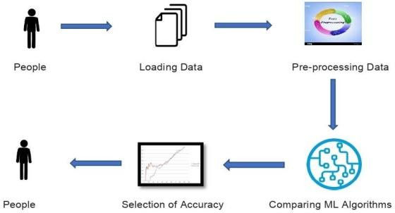
Fig 4.1: System Architecture
  - UML DIAGRAMS
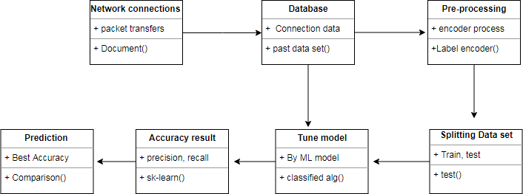
Fig 4.2: Class Diagram

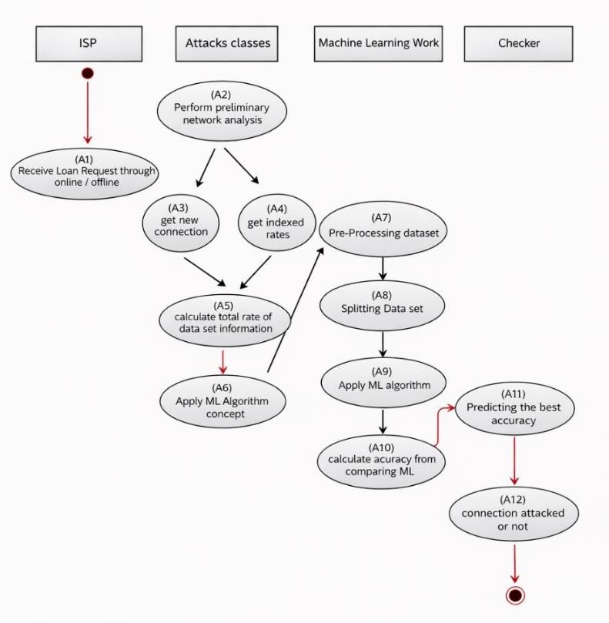

Fig 4.3: Activity Diagram

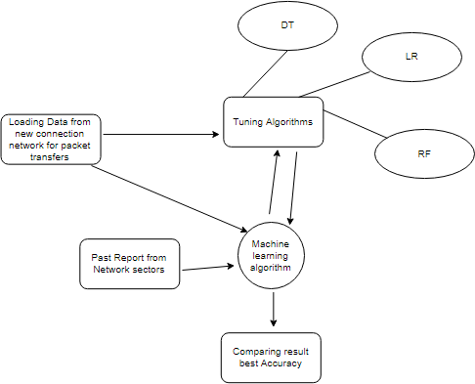

Fig 4.4 : Entity Relationship Diagram (ERD)

  - ALGORITHM USED
Logistic regression is a method of classification used to predict outcomes in terms of zero and one depending on some independent variables. The method predicts the probability of some events occurrence and assumes some things like binary outcome variables, low collinearity between predictors, and linear relations with log odds.
A decision tree is an algorithm for modeling data that creates a tree-like model in a recursive manner through division and conquering techniques. A decision tree uses a dataset and separates it according to its characteristics forming nodes which are either decision nodes or leaf nodes.

The random forest is another machine learning method that involves creating several decision trees and getting their prediction results through voting or averaging since it works on randomized datasets.
Support vector machine is a method that works in classification of data sets by creating optimal hyperplanes separating the data with the help of support vectors.

Graph neural network is a type of deep learning neural network made especially for dealing with graph data.

  - COMPARING ALGORITHM WITH PREDICTION IN THE FORM OF BEST ACCURACY RESULT
Comparing machine learning algorithms consistently is essential to select the best model. A test harness using Scikit-learn helps evaluate multiple algorithms under the same conditions. Techniques like K-fold cross-validation provide reliable accuracy estimates on unseen data. Visualization methods can further help compare model performance based on accuracy and variance.

Data preprocessing is crucial to convert raw data into a clean, structured format by handling missing values and ensuring compatibility with different algorithms. Commonly compared models include Logistic Regression, Random Forest, Decision Tree, Support Vector Classifier, and Graph Neural Networks.

Model evaluation uses metrics derived from the confusion matrix: True Positive (TP), True Negative (TN), False Positive (FP), and False Negative (FN). Accuracy measures overall correctness, while Precision and Recall evaluate prediction quality. The F1-score balances
Precision and Recall, especially useful for imbalanced datasets. Proper evaluation ensures fair comparison and selection of the most effective model.

  - MODULES DESCRIPTION

    - Data validation process and Visualization
    - Prediction of DoS attacks
    - Prediction of R2L attacks
    - Prediction of U2R attacks
    - Prediction of Probe attacks
    - Prediction of overall network attacks
    - GUI based prediction results of Network attacks

This part gives details of data validation, pre-processing, visualization, and prediction of several types of network attacks. Data validation is important to ensure that the model is accurate since it checks whether there are any missing or duplicate data, and data types. The process of separating validation data is crucial to improve model accuracy. On the other hand, data cleaning and pre-processing is crucial to convert the data from its raw state to an ideal structure. EDA and visualizations include using line plots, bar graphs, histograms, boxplots, and scatterplots to examine data and find patterns and relationship within them. Outliers have adverse effects on the performance of models. Finally, cross-validation ensures that data is divided into training and testing sets.

The modules also give an explanation of prediction of several forms of cyber-attacks including DoS, R2L, U2R, and probe attacks that are aimed at systems through overload, unauthorized access, privilege escalation, and information gathering respectively. Advanced cyber-attacks comprise several phases including exploration, exploitation involving phishing, and malware. Lastly, GUI systems are used in predicting network attacks and are better compared to CL systems because they allow easy interaction.
CHAPTER-5
RESULTS AND DISCUSSION, PERFORMANCE ANALYSIS

  - PERFORMANCE ANALYSIS

Performance Comparison of DOS Attack:
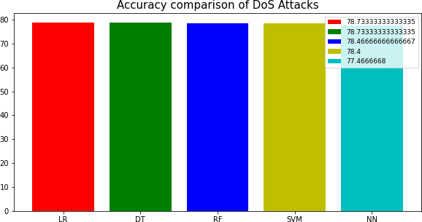
Fig 5.1: Accuracy comparison of DOS Attack

Performance Comparison of R2L Attack:
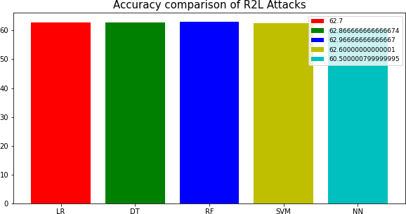
Fig 5.2: Accuracy Comparison of R2L Attacks

Performance Comparison of U2R Attack:
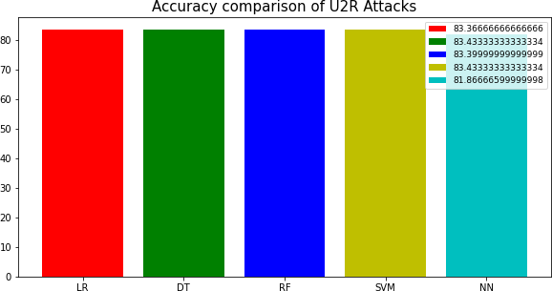
Fig 5.3: Accuracy Comparison of U2R Attacks

Performance Comparison of Probe Attack:
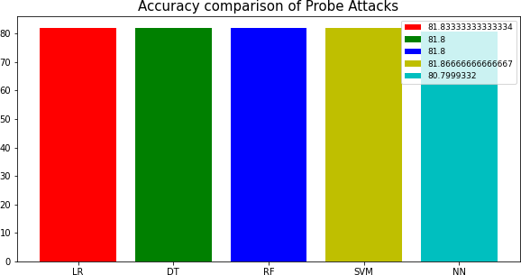
Fig 5.4: Accuracy Comparison of Probe Attacks

Performance Comparison of Overall Attacks:
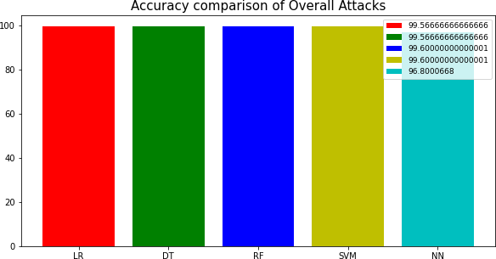
Fig 5.5: Accuracy Comparison of Overall Attacks

  - DISCUSSION
While discussions offer great opportunities to explore and discover new ideas, leading one can sometimes be stressful. Discussions are naturally unpredictable, and as teachers, we have to let go of some control over how information flows. Good preparation can help make discussions active and engaging without them getting out of hand. When planning a discussion, it’s important to think about more than just what students learn — also how they feel and how the physical setting affects their ability to share and exchange ideas effectively.
CHAPTER-6
SUMMARY AND CONCLUSION

  - SUMMARY
The scope of this project is to investigate a dataset of network connection attacks for KDD records for medical sector using machine learning technique. To identifying network connection is attacked or not.
  - CONCLUSION
The analytical process began with cleaning and preparing the data, handling missing values, conducting exploratory analysis, and eventually building and evaluating models. The highest accuracy on the public test set will be determined by comparing each algorithm's performance across all types of network attacks, which will help in predicting future results by identifying the best connections. This leads to some key insights regarding the detection of network attacks through each new connection. A prediction model using artificial intelligence is presented to surpass human accuracy and enable early detection. From this model, it can be concluded that area analysis and the use of machine learning techniques are valuable in creating prediction models that help network sectors shorten the diagnosis process and eliminate human errors.
  - FUTURE WORK
    - The network sector aims to automate the detection of attack packets during real-time transfers, using details about the connection.
    - I want to automate this process by displaying the prediction results through a web or desktop application.

    - The goal is to optimize the implementation within an artificial intelligence environment.

REFERENCES
- A. Kurakin, I. Goodfellow, and S. Bengio. (2016). “Adversarial examples in the physical world.” [Online]. Available: https://arxiv.org/abs/1607.02533.
- G. Zhang, C. Yan, X. Ji, T. Zhang, T. Zhang, and W. Xu. (2017). “Dolphin Attack: Inaudible voice commands.” [Online]. Available: https://arxiv.org/abs/1708.09537.
- P. He, W. Huang, T. He, Q. Zhu, Y. Qiao, and X. Li, “Single shot text detector with regional attention,” in Proc. IEEE Int. Conf. Comput. Vis. (ICCV), Oct. 2017, pp. 3066 3074.
- C. Yan, H. Xie, J. Chen, Z. Zha, X. Hao, and Y. Zhang, “A fast uyghur text detector for complex background images,” IEEE Trans. Multimedia, vol. 20, no. 12, pp. 3389 3398, Dec. 2018.
- K. He, X. Zhang, S. Ren, and J. Sun, “Delving deep into rectifiers: Surpassing human-level performance on ImageNet classification,” in Proc. IEEE Int. Conf. Comput. Vis., 2015, pp. 1026–1034.
- D. Storcheus, A. Rostamizadeh, and S. Kumar, “A survey of modern questions and challenges in feature extraction,” in Proc. NIPS Workshop, Dec. 2015, pp. 1–18.
- R. Shokri, M. Stronati, C. Song, and V. Shmatikov, “Membership inference attacks against machine learning models,” in Proc. IEEE Symp. Secur. Privacy (SP), May 2017, pp. 3–18.
- Y. Bengio and Y. LeCun, “Scaling learning algorithms towards AI,” Large-Scale Kernel Mach., vol. 34, no. 5, pp. 1–41, 2007.
- Y. Song, T. Kim, S. Nowozin, S. Ermon, and N. Kushman. (2017). “PixelDefend: Leveraging generative models to understand and defend against adversarial examples.” [Online]. Available: https://arxiv.org/ abs/1710.10766
- A. Kurakin et al. (2018). “Adversarial attacks and defences competition.” [Online].
Available: https://arxiv.org/abs/1804.00097
- A. Fawzi, O. Fawzi, and P. Frossard, “Fundamental limits on adversarial robustness,” in Proc. ICML Workshop Deep Learn., 2015, pp. 1–7.
- R. M. A. Ujjan, Z. Pervez, K. Dahal, A. K. Bashir, R. Mumtaz, and J. González, "Towards sFlow and adaptive polling sampling for deep learning based DDoS detection in SDN," Future Generation Computer Systems, vol. 111, pp. 763-779, 2020, doi: 10.1016/j.future.2019.10.015.
- "Software Defined Networking Definition." https://www.opennetworking.org/sdn- definition/ (accessed March, 2, 2020).

- S. Garg, K. Kaur, N. Kumar, and J. J. P. C. Rodrigues, "Hybrid Deep Learning-Based Anomaly Detection Scheme for Suspicious Flow Detection in SDN: A Social Multimedia Perspective," IEEE Transactions on Multimedia, vol. 21, no. 3, pp. 566-578, 2019, doi: 10.1109/tmm.2019.2893549.
- M. Nobakht, V. Sivaraman, and R. Boreli, "A Host-Based Intrusion Detection and Mitigation Framework for Smart Home IoT Using OpenFlow," presented at the 2016 11th International Conference on Availability, Reliability and Security (ARES), 2016.

